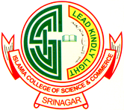
Email: hodcommerceicsc@gmail.com
PG DEPARTMENT OF COMMERCE
THE ISLAMIA COLLEGE OF SCIENCE & COMMERCE
SRINAGAR, KASHMIR.

NO.ICS/COM/5069/B3 Dated: - 03-10-2022

N O T I C E

The students of 3rd semester (backlogs) batch 2016-2019 are hereby informed through this notice that their internal examinations for Income Tax Law & Practice (e-filing of IT returns) shall be conducted on 07th of Oct. 2022 at 11:00 am in the Department of Commerce.

Sd/-
Dr. Seema Bashir
Head of the Department

